**Semester 1 2024/2025**

Subject : Technology and Information Systems (SECP1513)

Section : 08

Task : **ACADEMIC WRITING** on INDUSTRIES TALK 2

Group : 5

Project Title : SKILLS IN UNIVERSITY AND INDUSTRY

Group Members :

|  |  |
| --- | --- |
| NAME | MATRICS NUMBER |
| DASHITA A/P GAUTHAMAN | A24CS0065 |
| KISHANTINI A/P PARIMESWARIN | A24CS0097 |
| VIKASH RAJ A/L KATHIRASAN | A24CS0207 |
| MD TAMIM SHAMS | A24CS4025 |
| GAN YAO TONG | A24CS0075 |

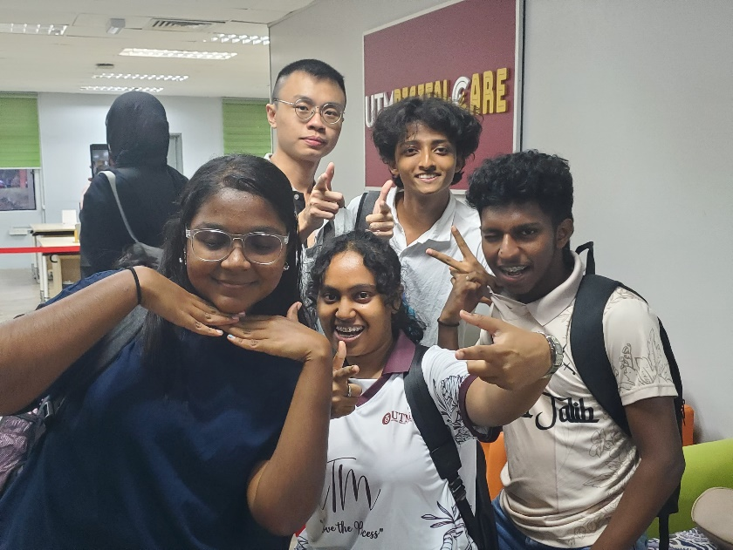

**ACADEMIC WRITING on INDUSTRIAL TALK 2**

**Description of the speaker experience:**

Nik Muhammad Habibullah, an entrepreneur and University of Technology Malaysia (UTM) graduate, guided his audience through professional and career development and more importantly on what it takes to attain success both in school and at the job. Nik joined the graphics department of UTM in 2005 and later explored the business side, where he founded NI Solution and Mikro Semiconductor, which are companies that provide hardware development and technological solutions. His projects include getting a career planning and placement platform Get Me Hired, and creating a comprehensive dialysis management system to be used in Malaysian health centers. Nik understands the uniqueness of the products and this provides him an opportunity to engage Graphics design, artificial intelligence and application of IoT where all of these are the industries requirements and features that will help him to cope with the changes.

**Basic Skills Needed for Computer** **Science:**

Training in computer science involves more than just tech skills. In addition to other computer skills, including programming experience, systems design knowledge, and understanding of structures and algorithms (Aasheim et al., 2009). In addition, cloud computing, integration in the IoT industry, tools and methods knowledge in cybersecurity also become elementary skills needed in the workplace (Suhaimi et al., 2012). Personal characteristics like analysis, adaptability and self motivation are key, among other skills and traits that help conquer challenges. In a more diverse variety of working environments, interpersonal skills, like collaboration and communication, are key to businesses (Abraham et al., 2006).

**Skills Required by Industry:**

The right mix of soft and hard skills is critical in any sectors. (Aasheim et al.,2009) argue that employers need workers who are well informed about new technologies, skills in social network and project management and possess problem-solving abilities. Soft skills such as an innovative leader, businessman, and pro-innovation are also important for success.Malaysians industries in particular, have been stressing the need for ICT graduates with practical knowledge as well as business skills, through government or private sector efforts to capitalize on the skills gap. (Suhaimi et al., 2012).

**How will you be successful in computer science in the next four years?**

1. The discussion emphasised on the significance of combining technical skills with flexibility and creativity. In the coming four years, I intend to solidify practical experience through internships, enhancing my technical knowledge in fields such as programming and cybersecurity, and keeping myself in proximity of industry developments to make sure I’m ready for a dynamic career in computer science.
2. Over the next four years, I plan to succeed in computer science by mastering fundamental concepts like programming, algorithms, data structures, databases, and networking, while strengthening my understanding of mathematics. I will focus on gaining hands-on experience through personal projects, internships, and hackathons to apply what I learn. I will stay current with emerging technologies such as AI, cloud computing, and cybersecurity, and earn certifications to enhance my skills. Being part of coding communities, collaborating with peers, and building my professional network will be crucial for my growth
3. My goal is to become a leader in sustainable product design, using computer science to create impactful solutions for Malaysia. Design thinking has shaped my problem-solving approach, emphasizing empathy, ideation, and iteration. This mindset helps me develop user-centered, effective solutions. To enhance my potential, I will gain practical experience through internships, refine my technical skills with advanced coursework, and build a professional network through industry conferences and mentor engagement.
4. I believe that in four years, I would be successful in computer science because I have mastered programming in multiple languages such as C++, Javascript and Python as well as gain a basic understanding of how computers work. I would have a great insight on hardware components, operating system principles, and networking concepts. Besides, looking into the future, I would have strong analytical and problem-solving skills to tackle complex challenges in computer science.
5. Over the next four years,I plan to excel in my computer science and graphics studies by mastering the fundamentals of programming,data structures,algorithms and discrete mathematics.My goal is also to learn the technical skills,but also develop a strong problem-solving mindset,critical thinking abilities,and effective communication skills.

**REFERENCES**

1. SURIATI BINTI SADIMON FC. (2024, December 24). *speaker2 part1* [Video]. YouTube. <https://www.youtube.com/watch?v=DsyUG9y2Lzg>
2. SURIATI BINTI SADIMON FC. (2024b, December 25). *speaker2 part2 cap* [Video]. YouTube. <https://www.youtube.com/watch?v=n7FlCdUKDjE>
3. SURIATI BINTI SADIMON FC. (2024c, December 25). *speaker2 part3 cap* [Video]. YouTube. <https://www.youtube.com/watch?v=xwkpzeuNHLI>
4. *Preparing for Entrepreneurship in IT Habib.pdf*. (n.d.). Google Docs. <https://drive.google.com/file/d/1NNoDzjBXzvdUaq8qzUibFCoy7AikdbbD/view?usp=sharing>

*(Nik Mohd Habibullah Bin Nik Mohd Nizam,n.d.)*

1. *1 ICT in Malaysia.pdf*. (n.d.-b). Google Docs. <https://drive.google.com/file/d/1uSTHxkLhRSgOwNwlBAdPPBdKB1KWu_r-/view?usp=sharing>

*(Mohd Adam Suhaimi, Muhammad Rabiul Hasan,Husnayati Hussin and Asadullah Shah,2012)*

1. *2 Knowledge and Skill Requirements for Entry-Level.pdf*. (n.d.). Google Docs. <https://drive.google.com/file/d/1hsmzldYdWyJteo8y1rhBo0Sx5qDZDQZf/view?usp=sharing>

*(Cheryl,L.Aasheim,Lixin Li,Susan Williams,n.d.)*